**LAB 1: TCP/IP Attack**

**Task 1: SYN Flooding Attack**

Lab Setup

Start the container using dcup

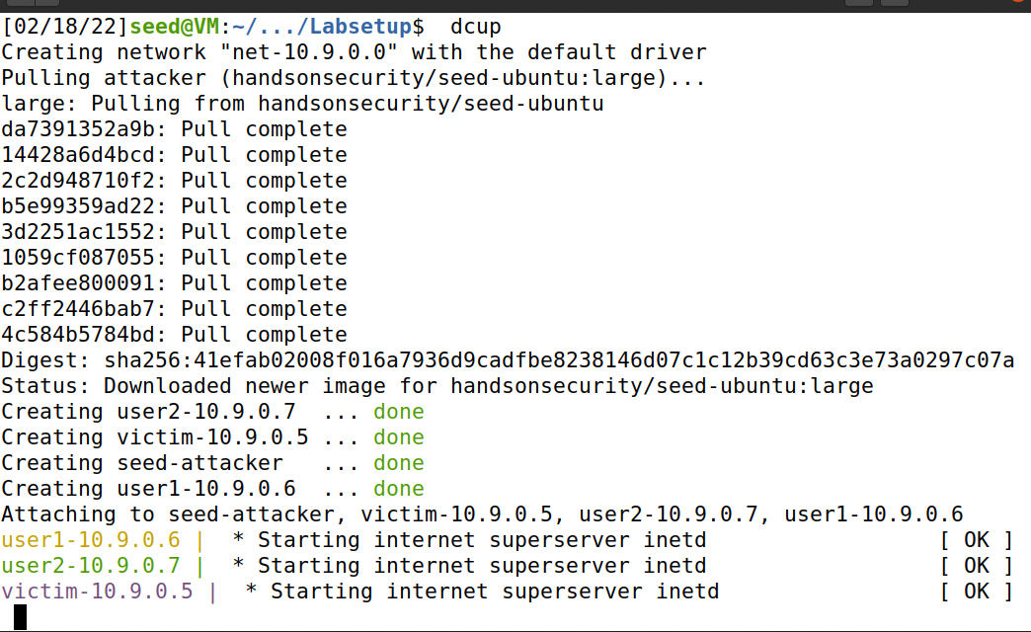

We use dockps to list the container ID

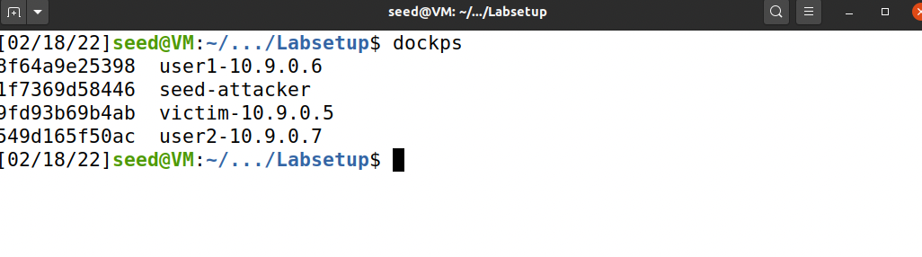

Docksh to start the shell of the container and we provide the container ID

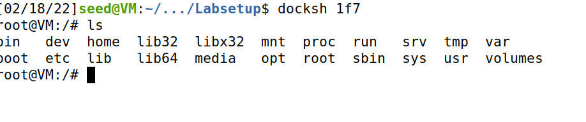

SYN flood is a type of DoS attack in which attackers flood a victim's TCP port with SYN requests but have no intention of completing the three-way handshake procedure. Attackers either use a spoofed IP address or abort the procedure entirely. Through this attack, attackers can flood the victim's connection queue, which is used for half-opened connections, i.e. those that have completed SYN and SYN-ACK but have not yet received a final ACK. When this queue reaches capacity, the victim is unable to accept any additional connections.

We flush the tcp cache in victim server because if the cache is present the SYN flooding would not work.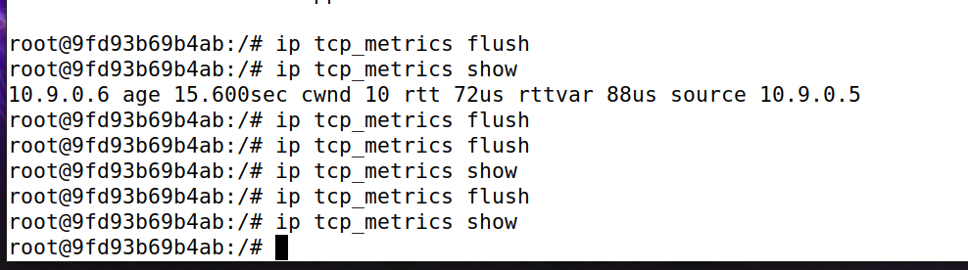

Now we go to attacker and execute the flooding. This sends spoofed TCP SYN packets with a randomly generated source IP address, source port, and sequence number as the source IP address, source port, and sequence number.

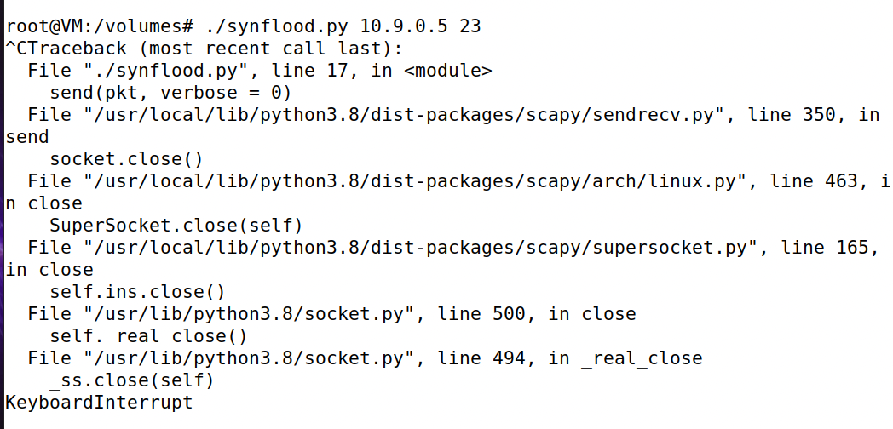

If we check wireshark now we can see lots of SYN packets being sent.

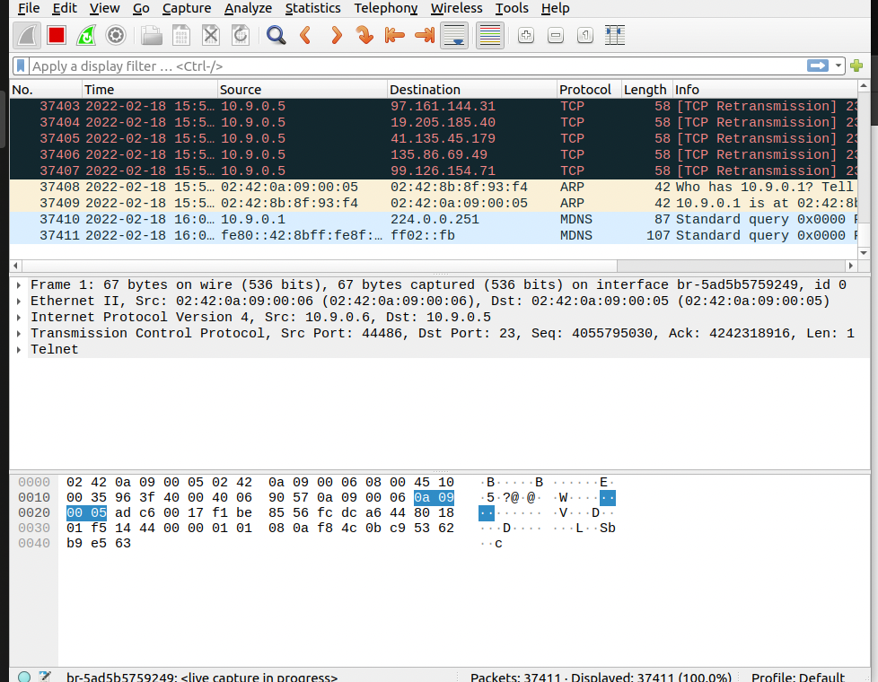

We connect to the user server via telnet and discover that there was initially no response. This is because the victim server is busy due to the syn queue being full.

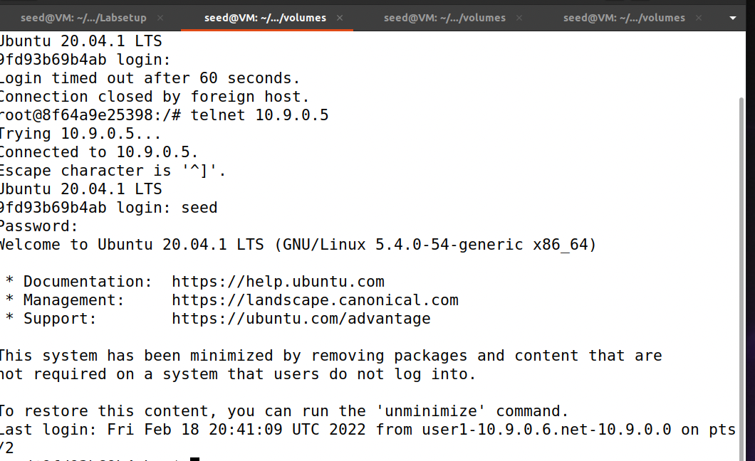

Now we're going to enable the cookie. When we execute to enable the cookie, there is no response because there is no buffer or SYN queue. Later on, we delete the cookie and check the cache, which indicates that the tcp protocol will allocate a single resource to this client. It makes no difference whether the SYN queue is full or not. Then we repeat the syn flooding attack and observe that there is no impact on the user side, indicating that the user can still login.

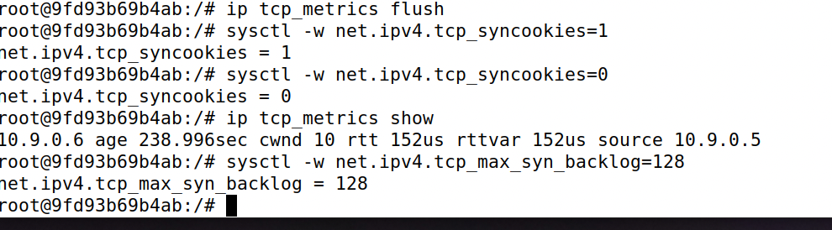

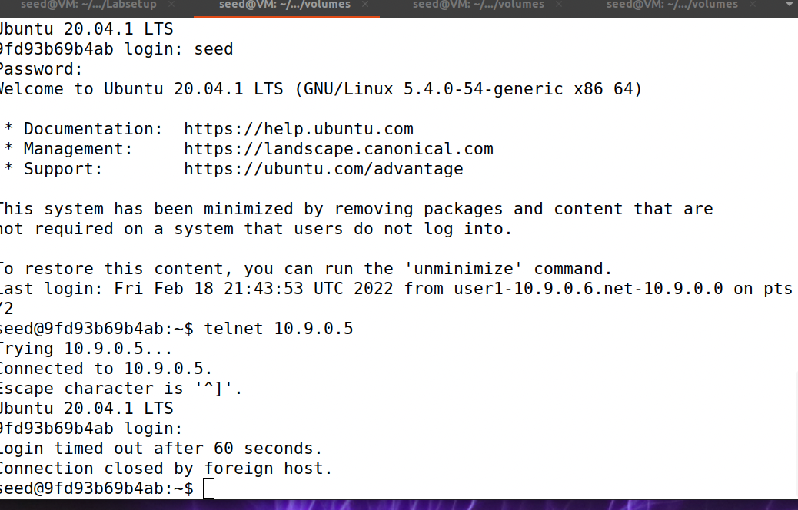

Now we disable the SYN cookie since we cannot reproduce the attack otherwise. Now we use the netstat command. There is no tcp connection with this state , this is a state when the receiver gets a SYN packets.

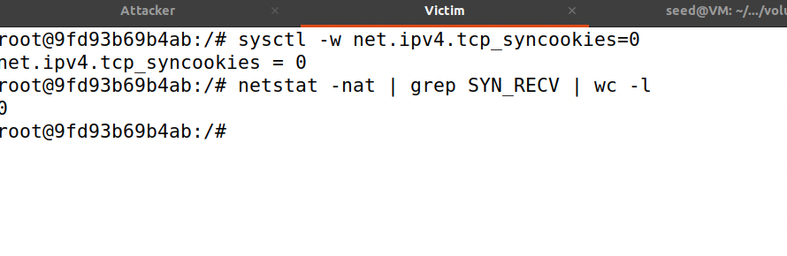

Now we launch the attack on the attacker server and sent many packets to the user server.

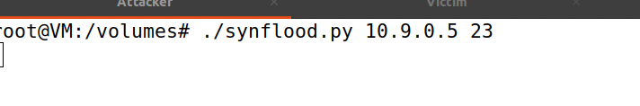

Here we need to wait to get a connection.

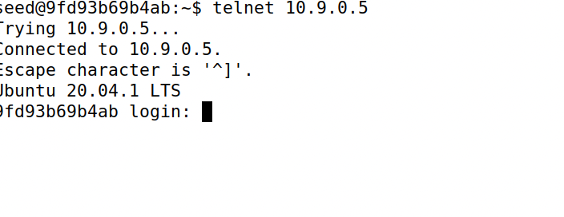

**Task 2: TCP RST Attacks on telnet Connections**

TCP RST Attacks can be used to terminate a TCP connection between two victims. For instance, if two users A and B have established a telnet connection (TCP), attackers can spoof a RST packet from A to B, effectively breaking the connection. To carry out this attack successfully, attackers must construct the TCP RST packet correctly.

Here, we launch a TCP RST attack from the VM in order to terminate an existing telnet connection between containers A and B. To simplify the lab, we will assume that the attacker and victim are both connected to the same LAN, i.e., the attacker can observe the TCP traffic between A and B.

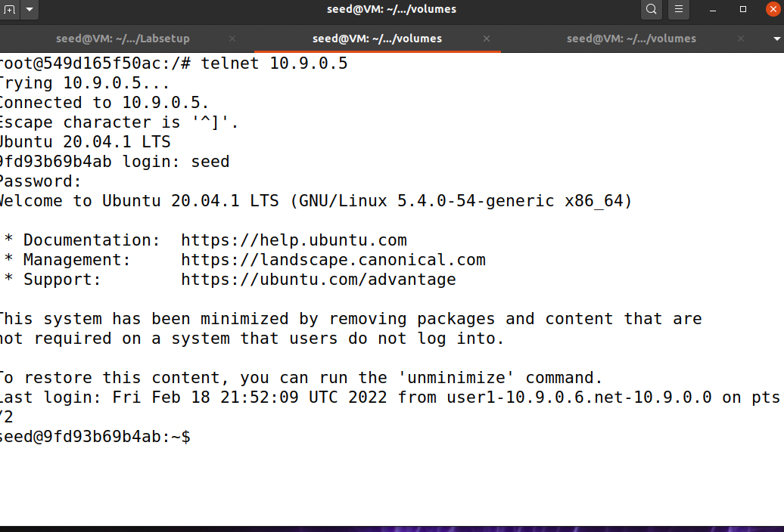

Here we select the last packet and copy the next sequence number and port number.

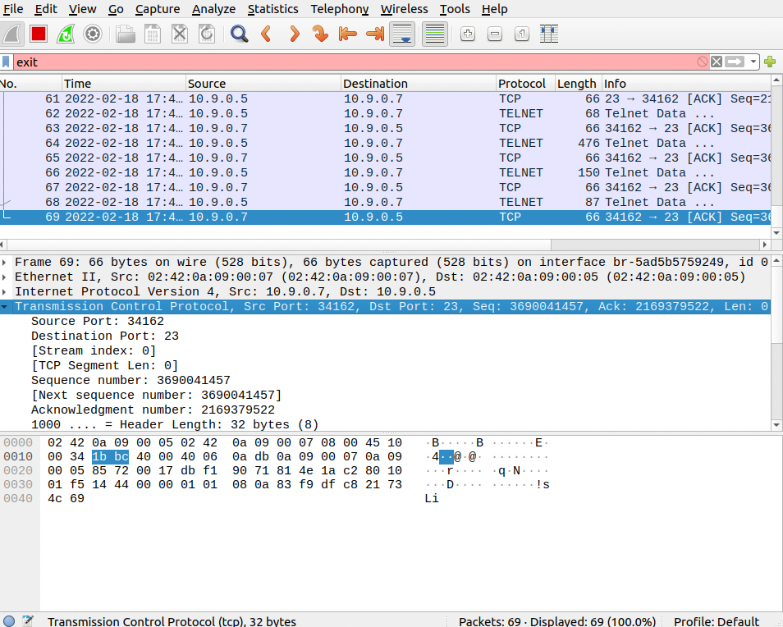

Now we copy those value and make changes to the code.

﻿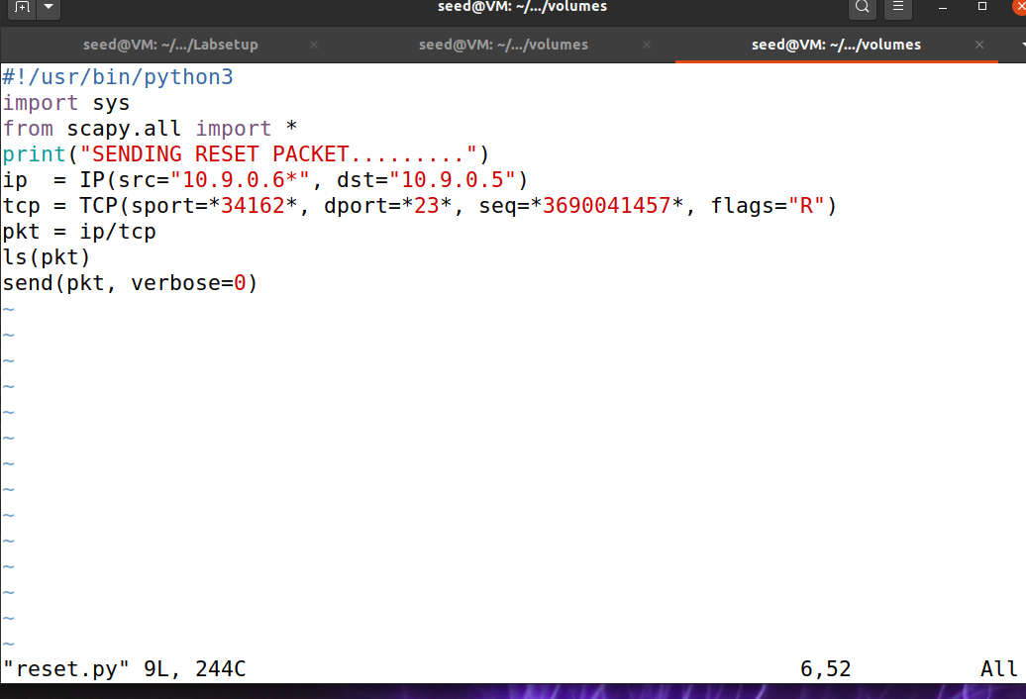

Now we launch the attack. Here we send a packet.

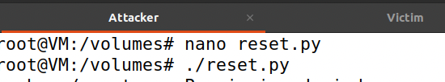

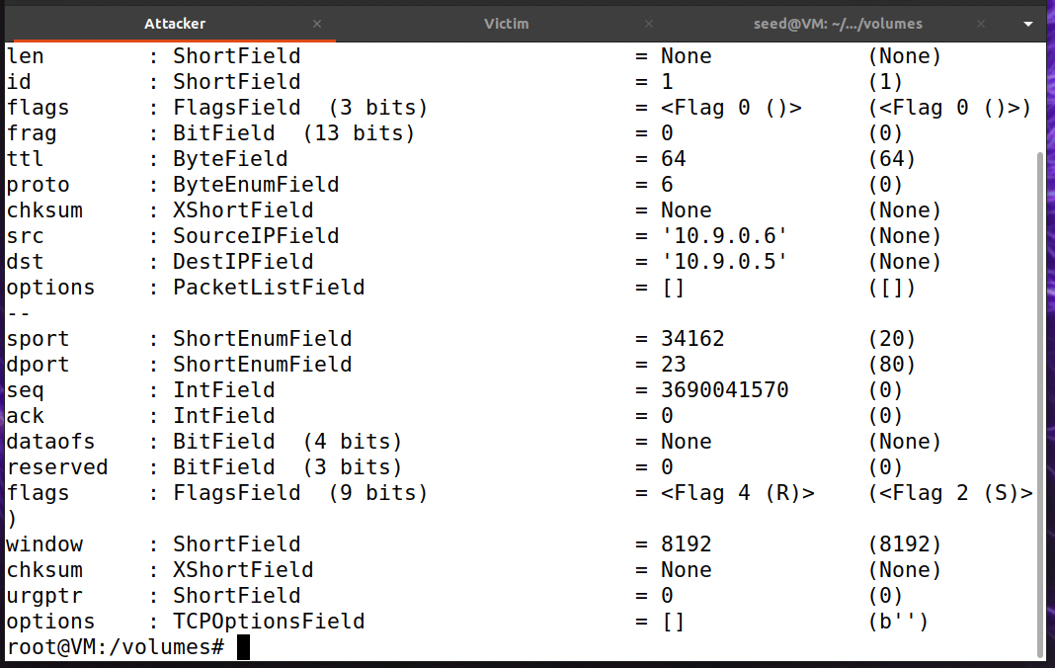

If we check the wireshark we can see the the red flag is the RST packet.

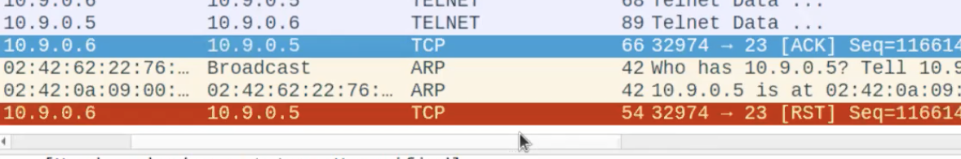

Now when we got o the user and type any command it shows that the connection has been lost.

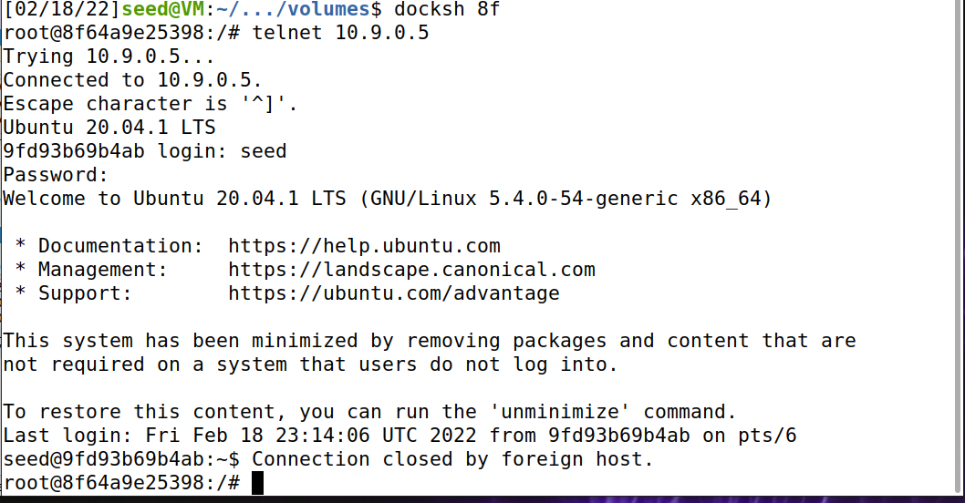

**TASK 3 : TCP Session Hijacking**

The TCP Session Hijacking attack's objective is to hijack an established TCP connection between two victims by injecting malicious content into it. If this connection is via telnet, attackers can inject malicious commands into it, causing the victims to execute them. We're going to demonstrate how to hijack a telnet session between two computers in this task. Our objective is to convince the telnet server to execute a malicious command sent by you. For the sake of simplicity, we will assume that both the attacker and the victim are connected to the same LAN.

Now we get the network ID by typing the command “docker network ls” and them make the necessary changes in the code a shown below.

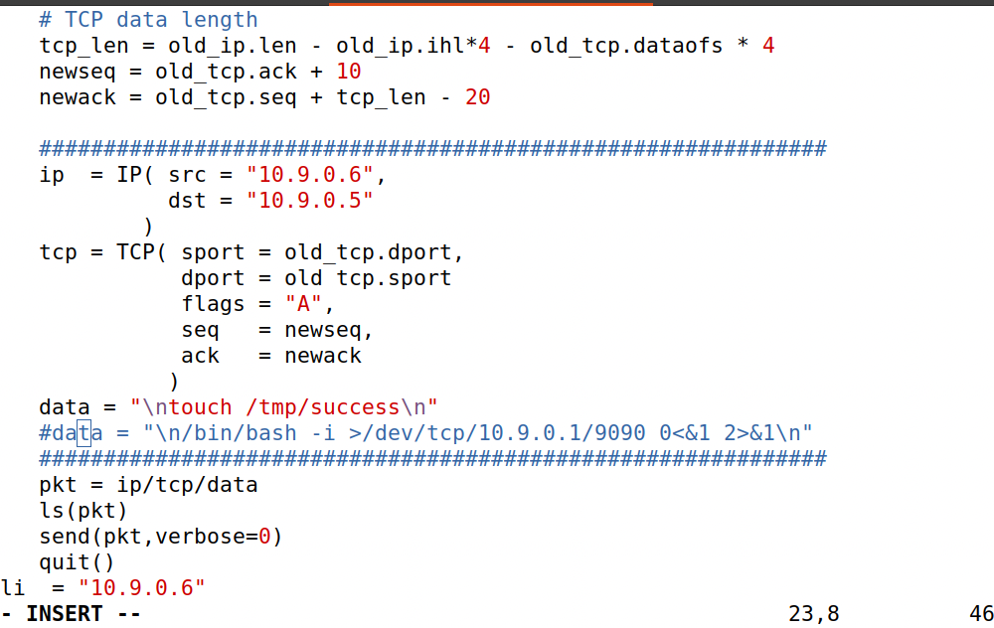

Now we launch the attack and spoofing has started.

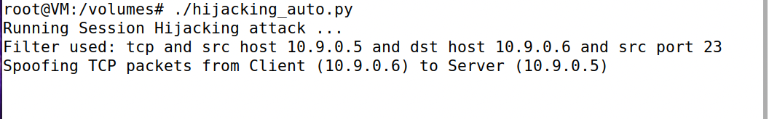

Now we check the tmp folder and it is empty now.

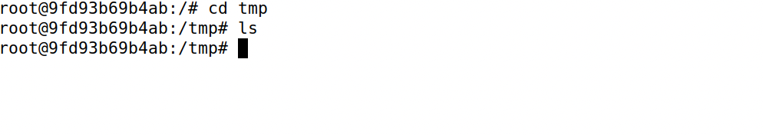

When we launch the attack we send a packet to the user server and we can capture the packet using Wireshark.

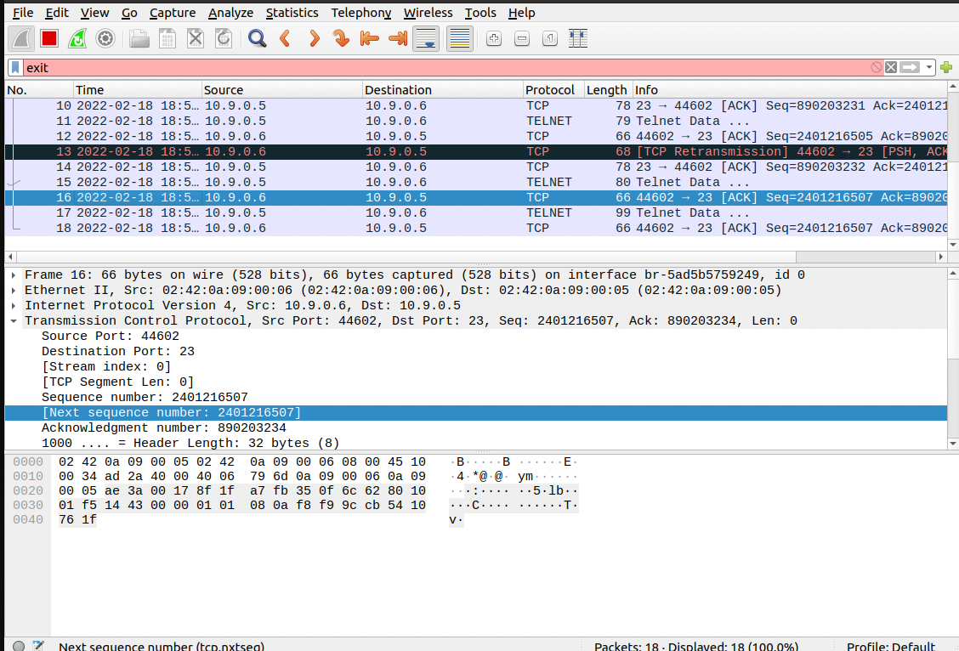

In below figure we can see that the attacker has spoofed the packets.

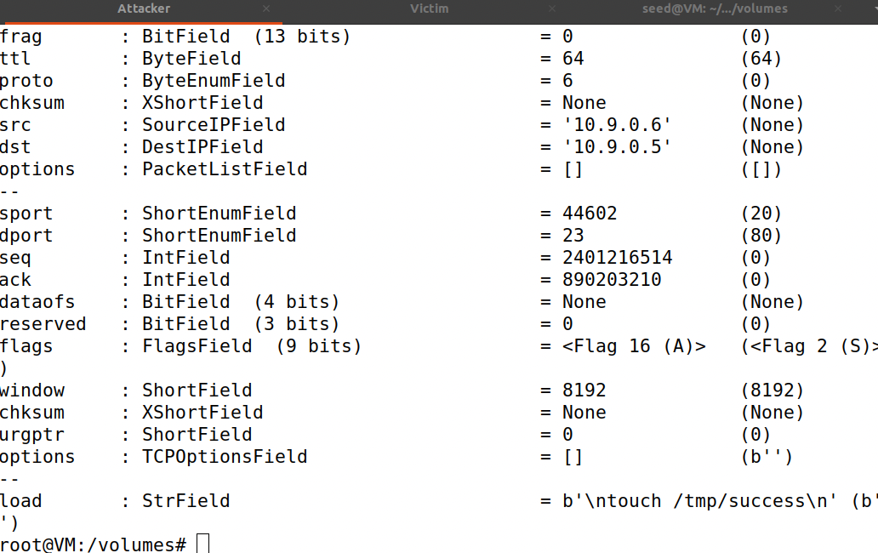

Now we type some characters in the client server as in the below figure in order to overflow the buffer.

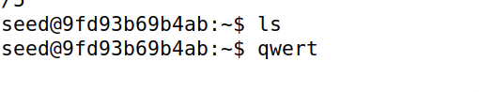

After this when we check the victim sever we can see that the success file has been created by the attacker.

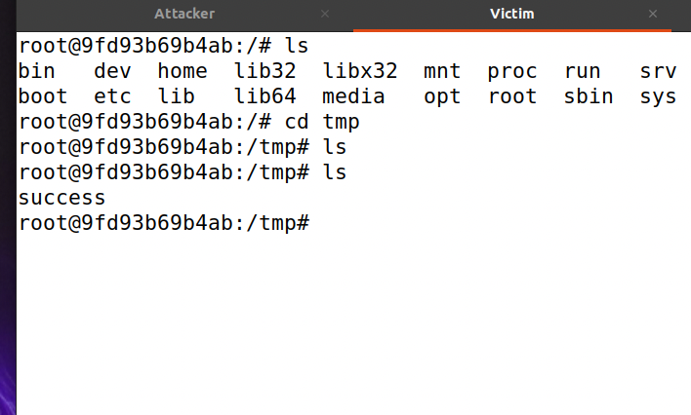

**Task 4: Creating Reverse Shell using TCP Session Hijacking**

When attackers are able to inject a command into the victim's machine via TCP session hijacking, they are not interested in running a single simple command; they are interested in running numerous commands on the victim machine. Clearly, executing all of these commands via TCP session hijacking is inconvenient.

What attackers hope to accomplish is to use the attack to establish a back door through which they can conveniently conduct additional damage.

A common technique for establishing back doors is to run a reverse shell from the victim machine, which grants the attacker shell access to the victim machine. A reverse shell is a shell process that runs on a remote machine and establishes a connection to the attacker's machine. This provides an attacker with a convenient method of gaining access to a compromised remote machine.

With the below netcat command we stated a listening tcp server on the attacker server.

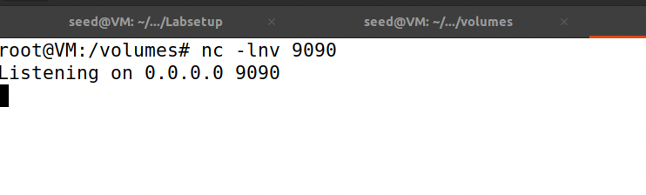

Now we launch the command .

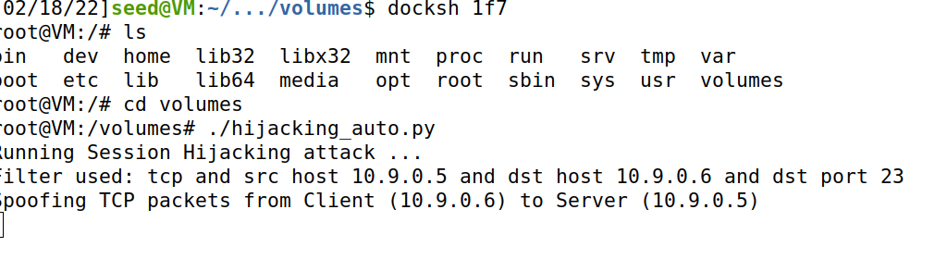

In the user we type some characters to trigger the buffer to deliver the application data.

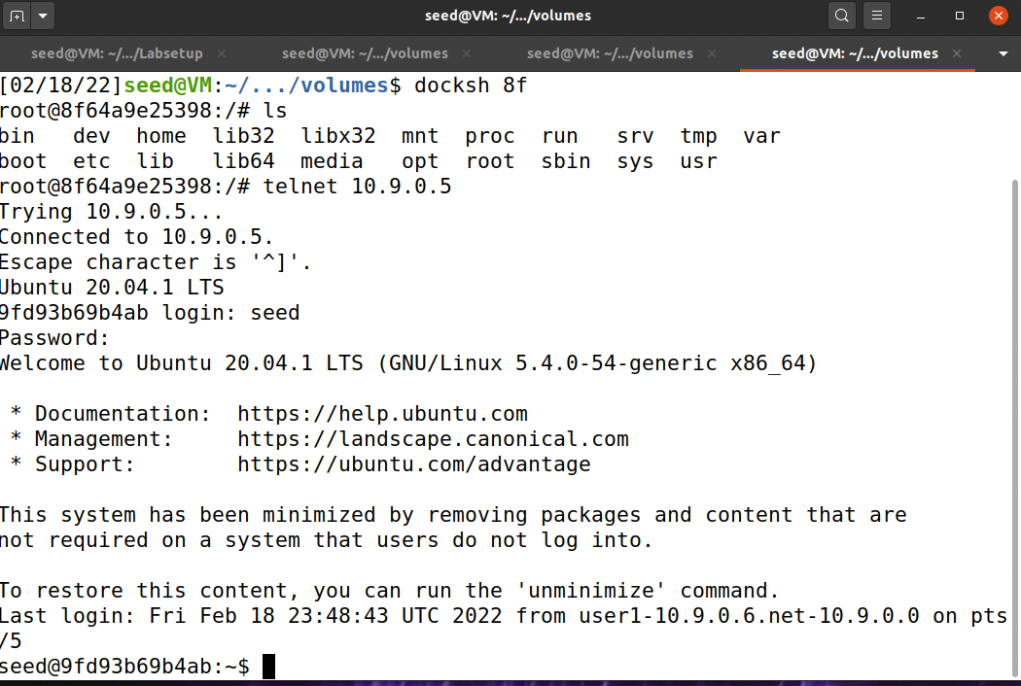

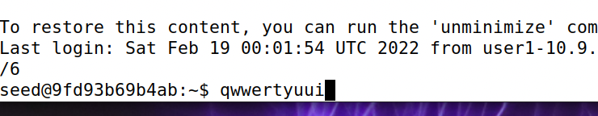

In the attacker container we established a reverse shell as we can that the connection received from the server. And when we type ifconfig we receive the ip address of the victim.

